

SINDH MADRESSATUL ISLAM UNIVERSITY (SMIU) DEPARTMENT OF SOFTWARE ENGINEERING(SE)

FALL 2026

COURSE TITLE: INTRODUCTION TO DATA SCIENCE
SEMESTER/SECTION: BSSE – 6B
COURSE CODE: CSC 218
INSTRUCTOR: MS. LARAIB WAHEED

Lab 3
Statistical Functions in Pandas

Objective
To understand and apply statistical functions available in the Pandas library for analyzing numerical data in a dataset.
Introduction:
Pandas provides many built-in functions to perform quick statistical analysis on datasets.
These functions help summarize and understand data distribution, central tendency, relationships, and variation.
Function | Description | Example
df.describe() | Returns summary statistics of all numeric columns | Mean, std, min, max, etc.
df.mean() | Returns the mean (average) of each numeric column | Average sales, average quantity
df.corr() | Returns correlation between numeric columns | Relation between sales & quantity
df.count() | Counts non-null (non-empty) values | Number of filled entries
df.max() | Returns maximum value of each column | Highest sale amount
df.min() | Returns minimum value of each column | Lowest sale amount
df.median() | Returns median (middle value) of each column | Median sales
df.std() | Returns standard deviation (data spread) | How much data varies
When you use something like this in pandas:
df.mean(numeric_only=True)
it means:
Purpose of numeric_only=True
This tells pandas to only calculate the mean for numeric (number-type) columns, like integers or floats — and ignore columns that contain text (like product names or categories).

Sales Data Code:
Step 1: Import Pandas

Step 2: Load the Sales Dataset
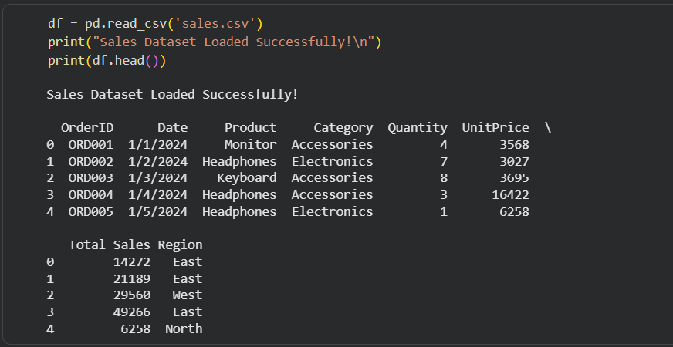
Step 3: Use Statistical Functions
Describe – Summary of all numeric columns
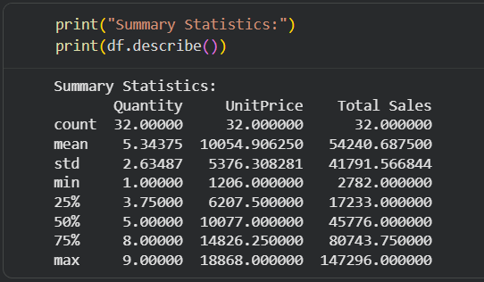
Mean – Average of each column
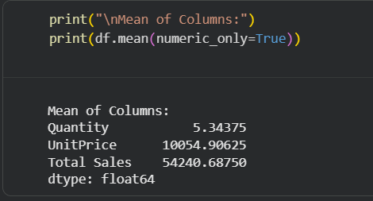
Median – Middle value
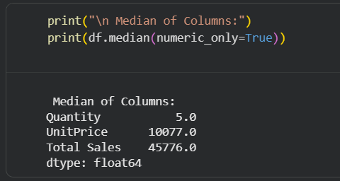
Max & Min – Highest and Lowest Values
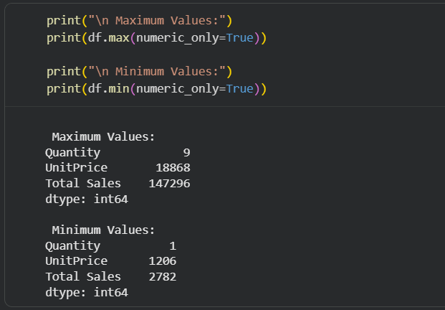
Count – Non-null values
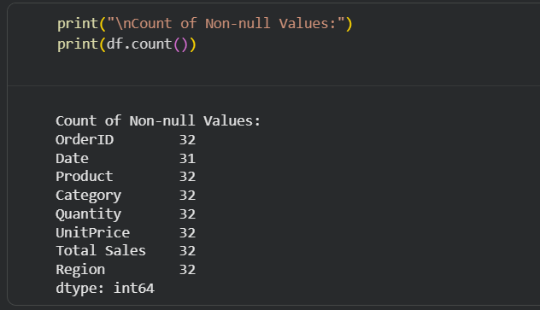
Standard Deviation – Data Variation
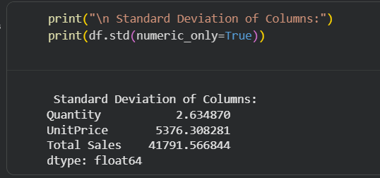
Correlation – Relationship between numeric columns
